15.69: a) To show this relationship is valid, take the second time derivative:
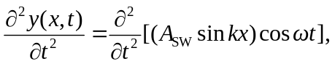
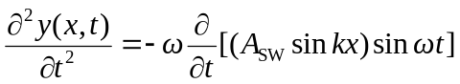
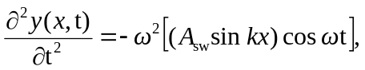
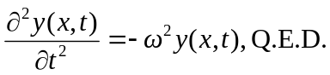

The displacement of the harmonic oscillator is periodic in both time and space.

b) Yes, the travelling wave is also a solution of the wave equation.

